Hands-On WEEK-9 DAY-43 Keerthivasan R

🏢 Background
A software company is developing a web-based Employee Management System. Requirements are evolving, and the team faces:
- Miscommunication between developers and stakeholders
- Delayed feature releases
- Unclear task ownership
- No visibility of project progress
- Difficulty managing team coordination

🚨 Problem
The company needs a structured Agile framework to:
- Organize team roles clearly
- Manage work in short cycles
- Track progress transparently
- Deliver features incrementally
- Improve team accountability

✅ Proposed Solution
Adopt the Scrum Framework, which includes:

👥 Roles
- Product Owner
- Scrum Master
- Development Team

🔄 Events
- Sprint Planning
- Daily Scrum
- Sprint Review
- Sprint Retrospective

📦 Artifacts
- Product Backlog
- Sprint Backlog
- Increment
Scrum divides the project into short time-boxed iterations called Sprints (2–4 weeks), ensuring continuous delivery and improvement.

🎯 Expected Outcomes
By implementing Agile and Scrum:
- Faster delivery of working software
- Improved customer satisfaction
- Better requirement management
- Increased team productivity
- Reduced project risk

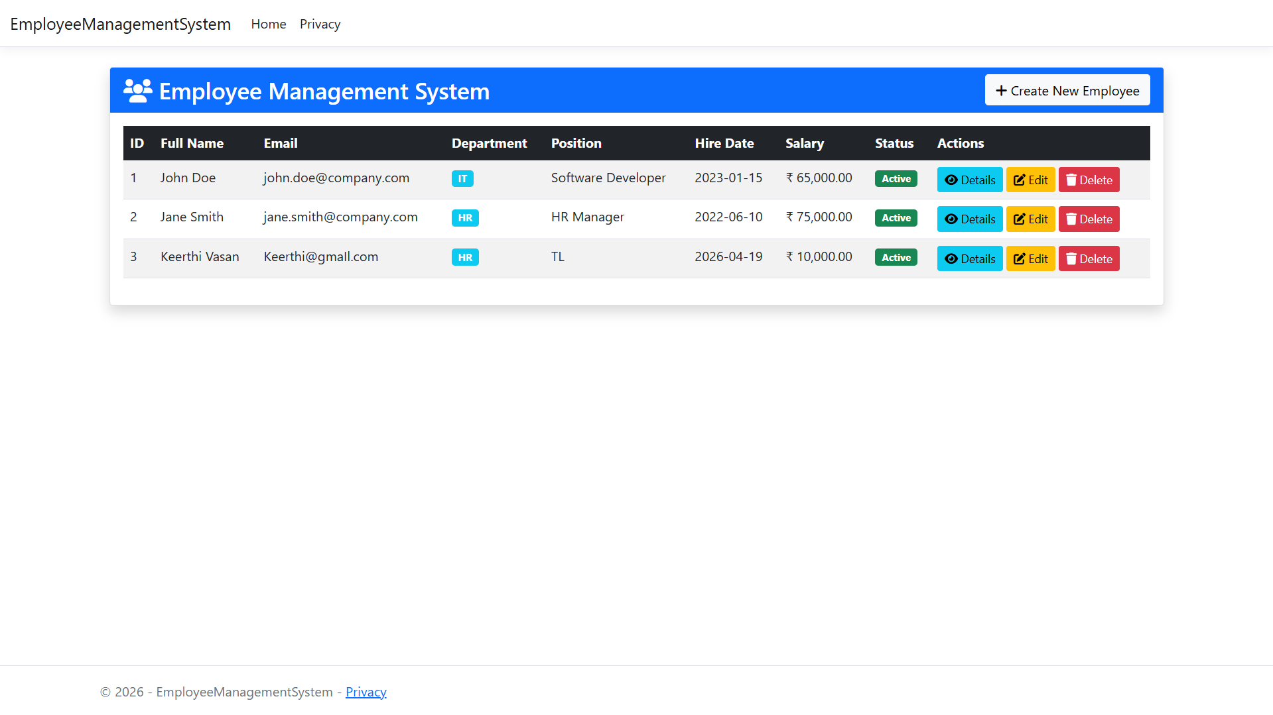
OUTPUT:

